**Assignment 1: Exercises for Monte Carlo Methods**

Student ID: Student Name:

Lectured by 梁上松, Sun Yat-sen University

**Exercise 1.**

The Monte Carlo method can be used to generate an approximate value of pi. Figure 1 below shows a unit square with a quarter of a circle inscribed. The area of the square is 1 and the area of the quarter circle is pi/4. Write a script to generate random points that are distributed uniformly in the unit square. The ratio between the number of points that fall inside the circle (red points) and the total number of points thrown (red and green points) gives an approximation to the value of pi/4. This process is a Monte Carlo simulation approximating pi. Let N be the total number of points thrown. When N=50, 100, 200, 300, 500, 1000, 5000, what are the estimated pi values, respectively? For each N, repeat the throwing process 100 times, and report the mean and variance. Record the means and the corresponding variances in a table.

蒙特卡洛方法可以用于产生接近pi的近似值。图1显示了一个带有1/4内切圆在内的边长为1的正方形。正方形的面积是1，该1/4圆的面积为pi/4。通过编程实现在这个正方形中产生均匀分布的点。落在圈内（红点）的点和总的投在正方形（红和绿点）上的点的比率给出了pi/4的近似值。这一过程称为使用蒙特卡洛方法来仿真逼近pi实际值。令N表示总的投在正方形的点。当投点个数分别是20, 50, 100, 200, 300, 500, 1000, 5000时，pi值分别是多少？对于每个N，每次实验算出pi值，重复这个过程100次，并在表中记下均值和方差。

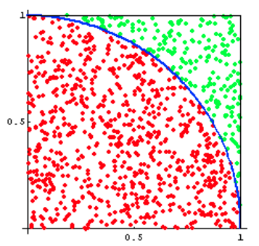

Figure 1 蒙特卡洛方法求解pi

**Exercise 2.**

An ant is trying to get from point A to point B in a grid; see Figure 2. The coordinates of point A is (1,1) (this is top left corner), and the coordinates of point B is (n,n) (this is bottom right corner, n is the size of the grid).

Once the ant starts moving, there are four options, it can go left, right, up or down (no diagonal movement allowed). If any of these four options satisfy the following:

(a) The new point should still be within the boundaries of the n×n grid

(b) Only the center point (4, 4) is allowed to be visited zero, one or two times, while the remainder points should not be visited previously (are allowed to be visited zero or one time).

If P is the probability of the ant reaching point B for a 7×7 grid, use Monte Carlo simulation to compute P. Pick the answer closest to P in value (assume 20,000 simulations are sufficient enough to compute P).

Figure 2 An ant is trying to get from point A (1,1) to point B (7,7) in a grid.

**Exercise 3.**

Given a system made of discrete components with known reliability (see Figure 3), what is the reliability of the overall system? For example, suppose we have a system that can be described with the following high-level diagram:

Figure 3 A system made of discrete components.

When given an input to the system, that input flows through component A or through components B and C, each of which has a certain reliability of correctness. Probability theory tells us the following:



And the overall reliability of the system is:

Create a simulation of this system where half the time the input travels through component A. To simulate its reliability, generate a number between 0 and 1. If the number is 0.85 or below, component A succeeded, and the system works. The other half of the time, the input would travel on the lower half of the diagram. To simulate this, you will generate two numbers between 0 and 1. If the number for component B is less than 0.95 and the number for component C is less than 0.90, then the system also succeeds. Run many trials to see if you converge on the same reliability as predicted by probability theory.